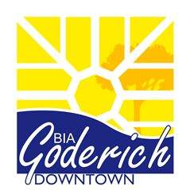

NOTICE OF
ANNUAL GENERAL MEETING

Property owners and businesses operating within the district of the
Downtown Goderich Business Improvement Area (B.I.A.) are cordially
invited to attend the Annual General Meeting of the Downtown Goderich BIA
Tuesday December 12 at 6:00 p.m. in the Menesetung Room of Town Hall,
57 West Street, Goderich, ON.
For the purposes of:
1/ submitting a draft budget for the 2018 fiscal year
2/ presenting the 2018 BIA Board of Management
3/ calling for nominations from the floor for persons wishing
to be appointed to the 2018 Board of Management
4/ to conduct such further business as may properly come
before the members at this time
An RSVP is appreciated. 519 440 0871. We look forward to seeing you there.
Posted on behalf of the Downtown Goderich BIA Board of Management.

